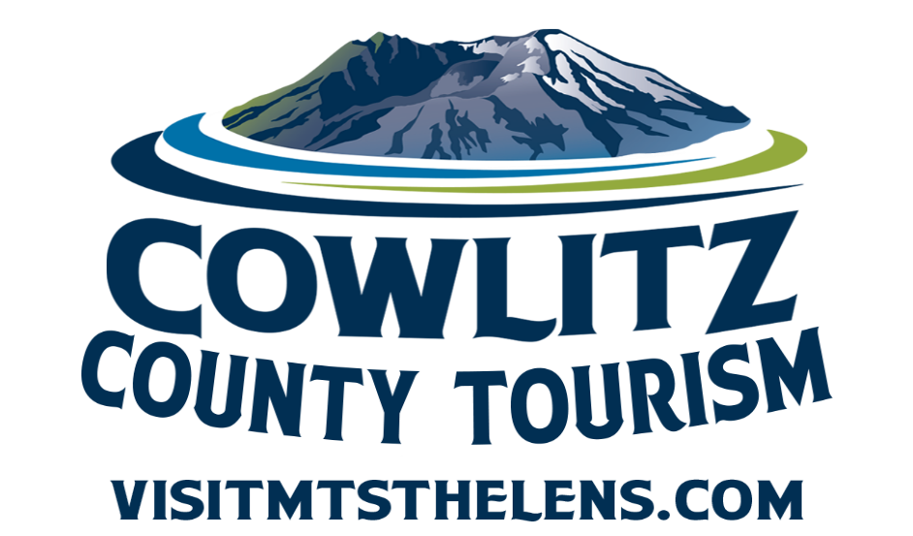

Tourism Large Grant

Application for 2026-2027 Funds

Completed application packages are due by 4:30 p.m.
Wednesday, March 25, 2026

Cowlitz County

1900 7th Avenue
Longview, WA 98632
360.577.3137
FREQUENTLY ASKED QUESTIONS

CAN WE APPLY FOR FUNDING FOR MORE THAN ONE PROJECT?
Yes. Applications may be submitted for more than one project. Applicants should not make multiple requests for the same project. Each application must be for a unique project.

ARE GRANTS ONLY FOR NON-PROFIT ORGANIZATIONS?
No, both Government Agencies and Non-Profit agencies may apply

WHAT CAN THE GRANT FUNDS BE USED FOR?
Grant funds can be used to support new or existing projects that encourage people from outside a 50-mile radius to visit Cowlitz County and stay overnight in local lodging.

Eligible expenses may be included, but are not limited to:
Construction or improvements that enhance visitor experiences, access, or safety (such as event infrastructure, attraction upgrades, or visitor amenities)
- Building Materials
- Infrastructure
- Equipment
- Contractor labor for the project
- Signage
- Event or program costs that help produce or enhance tourism-driven activities, such as staging, equipment rentals, or visitor-focused enhancements

HOW IS MY GRANT APPLICATION SCORED?
The scoring criteria is at the end of this application.

HOW LONG ARE MY GRANT FUNDS AVAILABLE?
The event or project must take place within the calendar year of 2026 - 2027.
You must submit for reimbursement by December 15, 2027.

WHAT IF I DON’T USE THE ENTIRE AMOUNT I AM AWARDED?
This is a reimbursement-based grant. You will only be reimbursed for eligible expenses, with proper documentation, up to the maximum amount awarded. Any portion of the award that is not used will remain with the County. If your project does not happen, the grant award will be considered null and void.
Cowlitz County

1900 7th Avenue
Longview, WA 98632
360.577.3137

M E M O R A N D U M

TO: Cowlitz County Citizens, Jurisdictions, Agencies and Organizations

FROM: Kim Bowcutt, Tourism Director

DATE: January 22, 2026

SUBJECT: Notice of Funding Availability

Cowlitz County is now accepting applications from public and nonprofit organizations for the Large Grant Events and Project funding that supports tourism within the County. This grant is intended to support larger scale projects that are outside of the scope of the Small Grants Program. Eligible uses include physical projects that generate overnight stays in Cowlitz County, as outlined in RCW 67.28.1816.

This program is supported by lodging tax revenues collected from hotel and motel stays in Cowlitz County. Funds will be available on or about May 1, 2026, and awarded on a competitive basis to qualified applicants able to complete their event or project by December 15, 2027.

Application Deadline:
Completed applications, including all required attachments, must be received by 4:30 p.m. on Wednesday, March 25, 2026. Submissions may be delivered by email or in person to:

Cowlitz County Tourism Department
1900 7th Avenue
Longview, WA

Late or incomplete applications will not be considered.

Award Notifications:
Applicants will be notified of funding decisions by Friday, April 17, 2026.

Questions or Assistance:
For additional information or technical assistance, please contact:
Dawn Smith, Tourism Coordinator
Phone: 360.577.3137
Email: smithd@cowlitzwa.gov
COWLITZ COUNTY TOURISM GRANT

PURPOSE

The Cowlitz County Tourism Grant supports projects that promote and enhance tourism in Cowlitz County. Eligibility is defined broadly to encourage diverse participation and innovative proposals. This grant is intended to help support a portion of a larger scale project.

Grant funds come from the County’s share of lodging taxes collected on hotel and motel room rentals within Cowlitz County.

This program is administered by Cowlitz County Tourism. Staff are available to provide technical assistance—please call 360.577.3137 for help.

SELECTION PROCESS

1. Application Review: Once the solicitation period closes, staff will review applications for completeness and eligibility.

2. Committee Evaluation: Eligible applications will be reviewed by the County’s Lodging Tax Advisory Committee (LTAC), which will make funding recommendations.

3. Final Approval: The Board of County Commissioners makes the final decision on approval and funding levels.

4. Contracting: For approved events, staff will work with applicants to develop contracts. After both the applicant and the County sign the contract, applicants will be notified to proceed.

IMPORTANT INFORMATION FOR APPLICANTS:

All contracts are reimbursement-based. Applicants must spend funds on approved items first, then request reimbursement as outlined in the contract.

Costs incurred before the County signs a contract cannot be reimbursed.

Applicants may only begin incurring reimbursable costs after a contract has been signed.

APPLICATION PACKAGE – Due by 4:30 p.m. on Wednesday, March 25, 2026.

ALL APPLICANTS SHALL SUBMIT:
• One copy of the completed grant application. Please email completed copy to smithd@cowlitzwa.gov or drop off to the Cowlitz County Event Center, 1900 7th Avenue, Longview, WA 98632
• Two letters of support, one must be from a hotel/motel or other lodging tax paying entity such as an RV Park or Campground. The other letter may be from a business, community group, partner or stakeholder.
Two letters of support/endorsement are required. No exceptions.
• Current 2026 W-9

ADDITIONALLY, PUBLIC AGENCIES (Cities & Towns) SHALL SUBMIT:
• Copy of meeting minutes approving project and authorizing application for funds.

Applications received without the above attachments will not be considered and WILL NOT be forwarded for review.

The application must demonstrate that the organization will supply at least 25% of the total project cost. The matching requirement may be met by a cash contribution, in-kind services, or a combination of both.

No project will be considered for funding unless it demonstrates that it can be completed by December 15, 2027.

Assistance program funds cannot be used to offset non-project operations and maintenance costs.

If an organization submits applications for more than one project, each one must have its own complete application package with attachments, and the applicant must rank the projects from most important to least important.

The program is open to applicants from public and non-profit entities with the demonstrated capacity to accomplish the proposed project. This includes agencies such as port districts, cities and towns, museums and galleries, historical societies, arts groups, chambers of commerce, and 501(c) 3 and 501(c) 6 non-profits.

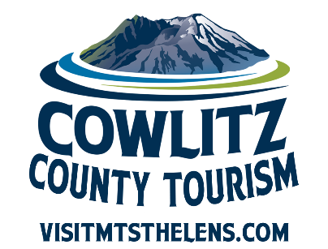
COWLITZ COUNTY TOURISM GRANT PROGRAM
Project Information
Project Title:
Project Sponsor / Contract Authority: ______________________________________
Address: _______________________________________________________

City: _________________________________State: ___________ Zip: ________________
Contact Person:
Email: __________________________Phone: __________________________________
Address:
City: _________________________________State: ___________ Zip: ________________

Date Range and Location of Event/Project

Sponsor is: Non-Profit Public agency

Have you received the Large Lodging Tax Grant before? _______
List Year, Project & Amount Awarded Below:
______________________________________________________________________

2026-2027 Project or Event Budget:

Request: $ Match: $ Total Project Budget: $

If you do not receive full funding, how would this affect your project or event?

Estimated visitors drawn: _Estimated overnight stays generated: _________
SCOPE OF PROJECT

Purpose of the Project:
(Describe what you plan to do and why)

Beneficiaries:
(Who will benefit from the project? How will they benefit, and why is it important?)

Evaluation Methods:
(How will you measure the success of your project? Examples: attendance numbers, hotel stays, participant surveys, media coverage, etc.)

Funding Focus:
(If you are requesting funds for a specific portion of a larger project, describe that portion here and explain how it fits within the larger project.)

Tourism Impact in Cowlitz County:
(Describe how your project will sustain or enhance tourism in the County. Be as specific and measurable as possible. For example: projected number of overnight stays, regional visitors attracted, partnerships with local businesses, etc.)
BUDGET INSTRUCTIONS

Provide a detailed budget for your event or project. Please keep in mind:

Personnel costs (wages, benefits, etc.) cannot be paid with County funds. However, you may include them as part of your matching contribution.

The County can fund certain costs such as:
- Building Materials
- Infrastructure
- Equipment
- Contractor labor for the project
- Signage
- Event or program costs that help produce or enhance tourism-driven activities, such as staging, equipment rentals, or visitor-focused enhancements

When listing your matching contributions, specify whether each item is provided as Cash or In-Kind. If you attach a budget, it must show the budget breakdowns as indicated below.

Event/Project Budget Template

Expense Category | County Request | Match – Cash | Match – In Kind | Total
Totals

⚠️ Notes for Applicants:

Be specific when listing in-kind contributions (e.g., donated labor, services, or materials).

Double-check that your totals balance correctly
COOPERATIVE COMMITMENTS FORM

Please provide details of your efforts to apply for current City LTAC funds, in the area where your project will be taking place.

Name of City: ___________________________________________

Date Applied: ___________________________________________

Amount Requested $ _________________

Status of Application: _________________

Contact Person at City: ____________________________________

Have you applied for City LTAC funds in prior years? If so, please list dates, amounts and results:

List Other Grants and/or Funding Partners for this Project including the amount and whether it is cash or in-kind and whether it is pending or receive

