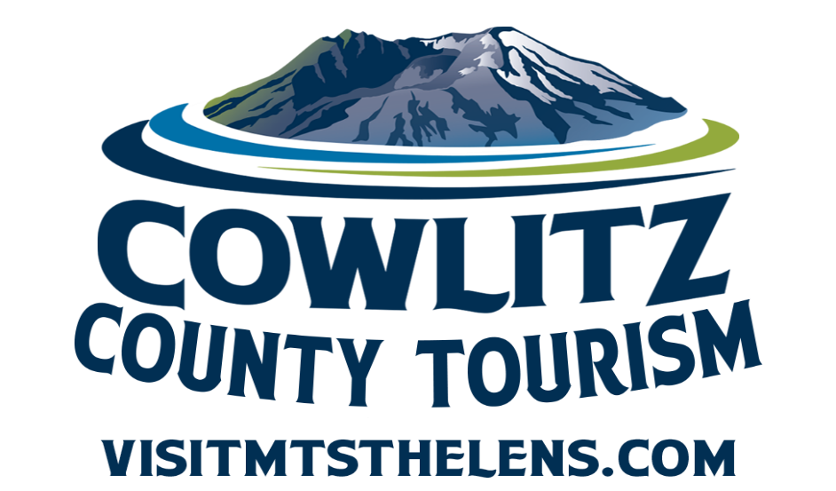

Tourism Grant

Application for 2026 Funds

Completed application packages are due by 4:30 p.m.
Wednesday, November 5th, 2025.

Cowlitz County

1900 7th Avenue
Longview, WA 98632
360.577.3137

TABLE OF CONTENTS
TOURISM LODGING TAX GRANT

Frequently Asked Questions…………………………………………………….…….3
Memo from the Tourism Department……………………………………………...4
Application Required Materials……………………………………………………….5
Application Purpose & Selection Process………………………………………….6
Application for Funds…………………………………………………………………….7
Grant Scoring/Judging Criteria……………………………………………………….11

FREQUENTLY ASKED QUESTIONS

CAN WE APPLY FOR FUNDING FOR MORE THAN ONE EVENT?
Yes. Applications may be submitted for more than one event. Applicants should not make multiple requests for the same event or project. Each application must be for a unique event or project.

ARE GRANTS ONLY FOR NON-PROFIT ORGANIZATIONS?
No, both Government Agencies and Non-Profit agencies may apply

WHAT CAN THE GRANT FUNDS BE USED FOR?
Grant funds will be allocated for new or existing events that bring people to Cowlitz County from outside a 50-mile radius and attract hotel stays. Allowed expenses can include marketing and promotion of the event.

DO WE GIVE BONUS POINTS FOR ANYTHING?
Yes, we give extra points for:
- Innovative events that represent an unusual approach or moves the County’s Tourism program in a useful new direction
- Events that occur outside of our peak season of May 15th to September 15th
- Family friendly events

HOW LONG ARE MY GRANT FUNDS AVAILABLE?
The event or project must take place within the calendar year of 2026. You must submit for reimbursement by December 15, 2025.

WHAT IF I DON’T USE THE ENTIRE AMOUNT I AM AWARDED?
This is a reimbursement-based grant. You will only be reimbursed for eligible expenses, with proper documentation, up to the maximum amount awarded. Any portion of the award that is not used will remain with the County. If your event is canceled, the grant award will be considered null and void.
Cowlitz County

1900 7th Avenue
Longview, WA 98632
360.577.3137

M E M O R A N D U M

TO: Cowlitz County Citizens, Jurisdictions, Agencies and Organizations

FROM: Kim Bowcutt, Tourism Director

DATE: August 29, 2025

SUBJECT: Notice of Funding Availability (NOFA)

Cowlitz County is now accepting applications from public and nonprofit organizations for event and project funding that supports tourism development and promotion within the County. Eligible uses include marketing and promotional activities for new or existing events/projects that generate overnight stays in Cowlitz County, as outlined in RCW 67.28.1816.

This program is supported by lodging tax revenues collected from hotel and motel stays in Cowlitz County. Funds will be available on or about January 20, 2026, and awarded on a competitive basis to qualified applicants able to complete their event or project by December 15, 2026.

Application Deadline:
Completed applications, including all required attachments, must be received by 4:30 p.m. on Wednesday, November 5, 2025. Submissions may be delivered by email or in person to:

Cowlitz County Tourism Department
1900 7th Avenue
Longview, WA

Late or incomplete applications will not be considered.

Award Notifications:
Applicants will be notified of funding decisions by December 31, 2025.

Questions or Assistance:
For additional information or technical assistance, please contact:
Dawn Smith, Tourism Coordinator
Phone: 360.577.3137
Email: smithd@cowlitzwa.go
COWLITZ COUNTY TOURISM GRANT

PURPOSE

The Cowlitz County Tourism Grant supports events that promote and enhance tourism in Cowlitz County. Eligibility is defined broadly to encourage diverse participation and innovative proposals.

Grant funds come from the County’s share of lodging taxes collected on hotel and motel room rentals within Cowlitz County.

This program is administered by Cowlitz County Tourism. Staff are available to provide technical assistance—please call 360.577.3137 for help.

SELECTION PROCESS

1. Application Review: Once the solicitation period closes, staff will review applications for completeness and eligibility.

2. Committee Evaluation: Eligible applications will be reviewed by the County’s Lodging Tax Advisory Committee (LTAC), which will make funding recommendations.

3. Final Approval: The Board of County Commissioners makes the final decision on approval and funding levels.

4. Contracting: For approved events, staff will work with applicants to develop contracts. After both the applicant and the County sign the contract, applicants will be notified to proceed.

IMPORTANT INFORMATION FOR APPLICANTS

All contracts are reimbursement-based. Applicants must spend funds on approved items first, then request reimbursement as outlined in the contract.

Costs incurred before the County signs a contract cannot be reimbursed.

Applicants may only begin incurring reimbursable costs after a contract has been issued.

APPLICATION PACKAGE – Due on November 5th 2025

ALL APPLICANTS:
• One copy of the completed grant application. Please email completed copy to smithd@cowlitzwa.gov or drop off to the Cowlitz County Event Center, 1900 7th Avenue, Longview, WA 98632
• Two references, one from a hotel or motel or other lodging tax paying entity
(RV Park or Campground)
• Current 2024 W-9

PUBLIC AGENCIES (Cities & Towns):
• Copy of meeting minutes approving project and authorizing application for funds.

Applications received without the above attachments will not be considered and WILL NOT forwarded for review.

The application must demonstrate that the organization will supply at least 25% of the total event cost. The matching requirement may be met by a cash contribution, in-kind services, or a combination of both.

No event will be considered for funding unless it demonstrates that it can be completed by December 15, 2026.

Assistance program funds cannot be used to offset non-project operations and maintenance costs.

If an organization submits applications for more than one event, each event must have its own complete application package, and the applicant must rank the projects from most important to least important.

The program is open to applicants from public and non-profit entities with the demonstrated capacity to accomplish the proposed event. This includes agencies such as port districts, cities and towns, museums and galleries, historical societies, arts groups, chambers of commerce, and 501(c) 3 and 501(c) 6 non-profits.

Please provide the following information as attachment:
(These are requirements for an application to be considered for funding.)

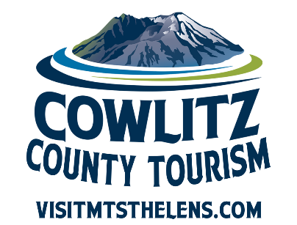
COWLITZ COUNTY TOURISM GRANT PROGRAM
Event Information
Event Title:
Event Sponsor / Contract Authority: ______________________________________
Address: _______________________________________________________

City: _________________________________State: ___________ Zip: ________________
Contact Person:
Email: __________________________Phone: __________________________________
Address:
City: _________________________________State: ___________ Zip: ________________

Date Range and Location of Event/Project

Sponsor is: Non-Profit Public agency

How many times have you received the Lodging Tax Grant for this activity in the
past five years? __________

2026 Project or Event Budget:

Request: $ Match: $ Total Project Budget: $

If you do not receive full funding, how would this affect your project or event?

Estimated visitors drawn: _Estimated overnight stays generated: _________
SCOPE OF EVENT

Purpose of the Event:
(Describe what you plan to do and why)

Beneficiaries:
(Who will benefit from the event? How will they benefit, and why is it important?)

Event Dates:
Start Date: _____________________ End Date: _____________________

Evaluation Methods:
(How will you measure the success of your event? Examples: attendance numbers, hotel stays, participant surveys, media coverage, etc.)

Funding Focus:
(If you are requesting funds for a specific portion of a larger event, describe that portion here and explain how it fits within the larger event.)

Tourism Impact in Cowlitz County:
(Describe how your event will sustain or enhance tourism in the County. Be as specific and measurable as possible. For example: projected number of overnight stays, regional visitors attracted, partnerships with local businesses, etc.
BUDGET INSTRUCTIONS

Provide a detailed budget for your event or project. Please keep in mind:

Personnel costs (wages, benefits, etc.) cannot be paid with County funds. However, you may include them as part of your matching contribution.

The County can fund certain costs such as:
- Design and layout of printed materials
- Printing
- Communications and promotions

When listing your matching contributions, specify whether each item is provided as Cash or In-Kind.

Event/Project Budget Template

Expense Category | County Request | Match – Cash | Match – In Kind | Total
Totals

⚠️ Notes for Applicants:

Be specific when listing in-kind contributions (e.g., donated labor, services, or materials).

Double-check that your totals balance correctly
COOPERATIVE COMMITMENTS FORM

Please provide details of your efforts to apply for current City LTAC funds, in the area where your event will be taking place.

Name of City: ___________________________________________

Date Applied: ___________________________________________

Amount Requested $ _________________

Status of Application: _________________

Contact Person at City: ____________________________________

Have you applied for City LTAC funds in prior years? If so, please list dates, amounts and results:

Other Grants and/or Funding Partners + Amounts:

GRANT APPLICATIONS WILL BE JUDGED BY THE FOLLOWING CRITERIA

1. Previous Events (10 Points)
If the applicant has previously received Cowlitz County Tourism grant funds, did they fulfill all contract requirements? Were required reports submitted on time, including spreadsheet report of overnight stays at local lodging facilities and a lodging tax project report? Is this request for repeat funding or for a new event/promotion? Any past infractions will result in reduced scoring on the current application.

2. Relationship to Tourism and Degree of Long-Term Impact (50 points)
• Ability of event to attract visitors to Cowlitz County and enhance tourism product
(15 points)
• Ability of event to increase transient room tax revenues (measured by increasing overall revenues from room tax by generating overnight visitor stays) (15 points)
• Ability of event to encourage repeat or future visits, or encouraging visitors to extend their stay (10 points)
• Event includes measurable and credible indicators and objectives (10 points)

3. Applicant’s Ability to Undertake the Event (20 points)
• Is the plan and budget realistic?
• Has the applicant identified metrics to indicate success?
• Does the event propose an efficient, economical use of the County’s funds?
• Does the event meet the minimum match of 25% or more?
• Does the applicant have the support of cooperative partners?
• Are there any previously demonstrated management and administrative successes?

4. Demonstrated Community Support and Public Involvement (20 points)
• Is there evidence of in-kind support?
• Is there evidence of endorsement by community groups and at least one hotel/motel?
(Two letters of support/endorsement are required.)
• Were there any guest focus groups, guest surveys, public workshops, meetings, or other methods to gauge guest interest or the potential for citizen involvement in the event?

Bonus Points (up to 15 points)
• Does the event represent an unusual approach, or does it move the County’s Tourism program in a useful new direction? (5 points)
• Event has the potential to increase room tax revenues during the tourism shoulder and/or off-season, specifically before May 15th and after September 15th (5 points)
• Event is family friendly (5 points)

COWLITZ COUNTY TOURISM GRANT – SCORING SUMMARY PAGE

Event/Project Name: ______________________________________

Applicant Organization: ____________________________________

Event/Project Title (if different): _____________________________

Scoring Reviewer Name: ___________________________________

Reviewer Affiliation (if any): _________________________________

Date of Scoring: ____ / ____ / ______

Total Scores

Final Score (out of 100): _____________ / 100

Bonus Points (out of 15): _____________ / 15

Overall Score (including bonus): _____________ / 115

Reviewer Comments (Optional):

Please provide any notes, concerns, or commendations that could assist the grant committee in final decisions. Use this space to clarify scoring decisions or highlight unique aspects of the application.

___________________________________________________________________________________________________________________________________________________________________________________________________________________________________________________________________________________________________________________________________________________________________________________________________________________________________________________________________________________________________________________________________________________________________________________________________________________

